# Interview Questions

//First Learn Ethics of Online Interview

Greeting : Hello ,Good Afternoon ,It’s Nice to meet you.

1. Introduce Yourself: (Motto-How you represent yourself)

Sure, My Name is Bhautik Parmar, I am a resident of Mumbai, I completed My B. Tech in Electronics and Telecommunication Engineering.

I have approx 2 years of experience in the software industry and specialized in web development.

Currently, I am working in TCS and contributed to a couple of projects, prior to that I also worked as Frontend Intern in a small startup.

I have also made a couple of projects using reactjs, and Node js.

I also have published 1 IEEE Paper with my Name during my graduation.

I wish to use my technical acumen/ability to contribute to a team that works at scale and creates a positive impact on society.

How are You?

Feeling positive and looking forward to starting a new chapter in my life

1. Tell about project roles and responsibilities:

As I mentioned I worked as developer in IADB Account, I contributed to my project as a frontend engineer, At a starting of my work I have done regression/manual testing in my project and then Developed Graphical UI Dashboards Using Angular Framework.

What are your digital skills?

Programming, Web Development,I also have some general Idea of Machine Learning/Deep learning and cloud.

In Programming: Python/Javascript

In webDevelopment: Angular framework, git ,sql,HTML,CSS.

Get some knowledge of all above things.

Technical prepatation:

Diffence between var,let and const:

var is globally scoped and functional scope and changing in functional scope also reflect that change globally, while in let it doesn’t happen it has functional scope only. And Const cannot be redeclared.

What is Machine learning?

As Humans Can learn from past Experience, similary humans can train machine to learn from past data is called machine Learning.

1. Supervised Learning : example IRIS Dataset, petal length, petal width, sepal length, sepal width.

Algorithms: Logistic Regresion/ Linear Regression, navies bayes algo.

2. Unsupervised learning : No labeled data is there, It tries to make cluster/Grouping the data which has similar charecteristics.

e.g Consider a baby has a family dog, few week later a relatives came to babys house with his pet dog, baby don’t recognize his pet is dog, but looking at dogs 2 ears,4 legs, mouth baby cluster that this thing is animal which is dog.

e.g K-Means Clustering/ Neural networks.

3. reinforecement learing: Here agent perform some action on environment and get reward or penalty, so based on that rewards and penalty it will make new policy and perform next action in this way agent learns.. e.g carrot/ mahatma Gandhi Note in P.K movie.

In Games it used Mostly like On each step in game we can get positive and negative rewards.

DEEP Learning:

When we have small amount of data we use Machine learning, When we have Large amount of data we use Deep learning.

It is a subset of machine Learning which uses Artificial Neural networks like CNN(Convolution neuaral networks) and RNN(recurrent neural Networks).

CNN used for feature Extraction of an Image. Its Includes convolution, pooling, Fully connected layer etc..

RNN is mostly used for Text Generation from an Encoded vector.

Data Science: Giving some Insights from Raw data,

e.g If we have data of latitude and longitude of given area and have data of all shops, restaurant, malls in that area then we can predict insights that, 50% people goes for dinner in Sunday, 30% people go for shopping on Wednesday etc..

Cloud Computing: **cloud computing** is the delivery of **computing** services—including servers,deploying sites, storage, databases, networking, Virtual desktops over Internet. With pay as you go pricing.

Instead of buying big servers and storages and maintain it we can use clound provider such as AWS/ GCP/ Azure.

Two types of Clound Computing:

1. Deployment Model:

a. Public Cloud: (BUS) The cloud Infrastructure is made available to general Public over the internet and its own by cloud provider e.g AWS, Azure, GCP .

b.Private Cloud: (OWN CAR) Cloud Infrastructur is Exclusively operated by Single organization.

c.Hybrid Cloud: ( Taxi ) Organization which uses Both.

2. Service Model:

a. IAAS (Infrastruture as a Service): Cloud Offers Essential Computer storage and networking Resources, like storage, VMs etc.

b. PAAS(Platform as a Service) : it provide runtime environment for developing testing and managing applications e.g heroku, App Service( i.e deployment purpose)

c. SAAS (Software as a Service): Software as a service (SaaS) allows users to connect to and use cloud-based apps over the Internet. Common examples are email, calendaring and office tools (such as Microsoft Office 365).

1. T factor: My current T-Factor is 2.01 and working to Improve more.
2. I evolve score: I have 890 Learning Points with completing 55 course, 35 competency with 7 certifications in ievolve.
3. Certifications/Accomplishment:

Certificates: 1. few Certification on I evolve Itself Includes Python/Java/ Security/Language/Agile Courses etc.

2. I Have Two Hackreank Angular Certification of Both Basic and Intermediate level.

3. During College Days I have done Certification of Python/Deep Learning Courses.

1. Competitions/Hackathon participation:

Participated in couple of Weekly Hackathon Tests on Fresco Play, And also Participated some of External Coding Competitions.

1. External events participation: Couple of Coding Competition
2. Why DCA: Great Opportunity for junior Engineers to Boost their career financially as well as professionally.
3. If not selected what will you do: I am trying my best and I hope that it will not happen. This is 2nd Try of Dca, I also Attended In January Unfortunately I Failed, After Lots of hardwork I cleared exam, Anyway, I will Analyze my Mistakes, What’s goes wrong ,learn from it and continue.
4. Your achievments before and after Joining TCS?

I have Published an IEEE Research Paper during college about My Final year Project i.e “Encoder Decoder Architecture of Image Caption Generator” . And That’s Get Accepted.

And Now Recently I have Cleared 1.99 Milestone of T-Factor In 1st Attempt only.

1. How will you be loyal to tcs?

I have Pride of my work, I will Do my Job with Integrity and ethics. I will Work hard and **always Keep learning attitude**, And Try my best to complete my given task on time.

1. What are your strengths and weakness and how will u overcome your weakness?

Strength: I Am a good team worker( because I Understand that in order to achieve some difficult project you must work with other people and bring in their experience and skills.)

I have good collaborative nature and flexible person, I am Honest trustworthy and loyal. And Commercially Aware.

Weakness: I asked To many Questions, to Clarify Something.

I am bad at reading Tutorials/Blogs to learn something, I Always Prefer Video Lessons to understand something.

I am bad at creativity.

Steps to Overcome weakness:

I try to concentrate More If someone Explaining something.

I try to read tutorials also after Every Video Lessons of that particular Topic.

1. What Motivates You?

Appreciation for my Work that Motivates me alot, And *Small* progress and Completing some Challenges motivates.

I have my some Personal and Professional Goals that Motivates me. Like I am Saving Money for buying a new Flat, Want to become an Important asset for my company, so if I not perform well then I won’t achieve that goal.

1. Where do u see yourself in 5 years? And how will you reach there?

For the next couple of years I want to improve myself in this job and improve my skills around it after which I would like to take additional responsibilities and help others in the organization with my expertise.

However after this experience I would also like to Lead Projects and Collaborate with Major Clients for Businesses Meets.

1. Reason behind Leavin your last Job?

In order to enhance my skillset I am looking for better opportunity

1. Why Should we Select You?

You should select me because I have skills and qualities and learning enthusiasm that a good Software Engineer must have. I will work hard and contribute to the team objectives and I will focus in all work that I undertake for company. I have ambitious plan for the future and I know the only way to achieve my goals if I work hard and get a good employment history behind me.

1. Do You have any Question For Us?

Yes thank you for giving the opportunity to ask.

How would you describe your company environment for success? for HR

Does the company offer any benefits to the employess for work life balance.?

And Lastly What advice would you give to someone like me who wants to perform well in this role?

1. Are You a team Player or Leader and Y?

I believe right now I am currently a strong Team player, I always collaborate to meet the team Objective, I would also like to lead teams as my experience increases in this field.

1. Describe Your work policies Ethis:

I am honest and sincere person with positive outlook towards life. I am very organized and efficient and I am good in team work also.

1. What Most Challenging Task You have done Recently?
2. Tell me about your ability to work under pressure?

I am not naturally efficient under pressure but over the course of my career, I have learned to work well under pressure, I believe by planning and proper time management and also asking help from my team member can reduce the panic around deadlines.

1. why are you leaving your current Job?

I want to leave my current job because I am ready for a fresh challenge with a new and exciting company and looking for better opportunities. I have thoroughly enjoyed working with TCS and I learned a lot of things from there. I think I am ready to take more responsibility.

If you don’t know the Answer then tell that sorry I don’t know the answer but if possible I will get back to you after the Interview.

WHAT IS SDLC?

Below Image also known as Waterfall Model

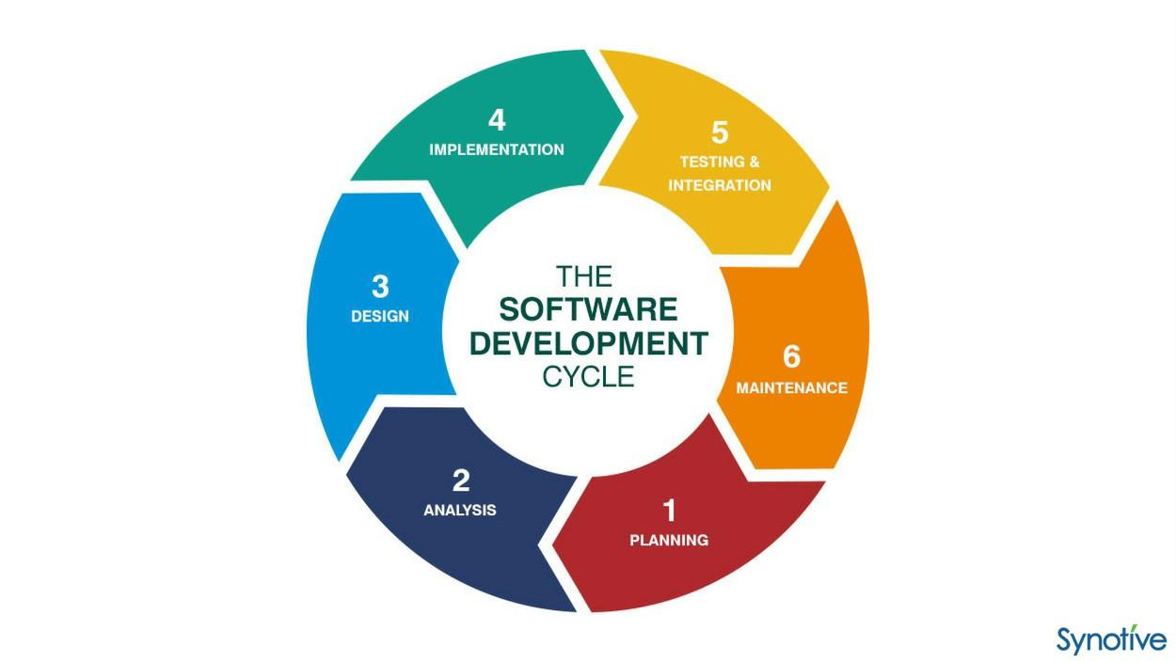

What Is Agile?

Agile is type of SDLC method which follows few values and priciples while developing Softwares for Customers.

Those who follows this Values and Principle are known as Agile and we have to be Agile

Values are:

1.Working software over comprehensive documentation

2.customer collaboration over contract negotiation

3. respond to change over planning, say yes to client if they want to change something in their projects.

Principles are:

1. we have to satisfy customer with early and continuous delivery of a valuable software

2.welcome changing requirement

3. Try to Deliver software in Phases.

Scrum is framework to Implement Agile

Commercialy Awareness of Tcs:

1. How Tcs Makes Money and do Their Business:

TCS is Software Outsourcing company means Different Companies outsource there IT part to TCs for Handling.

TCS gives approx. 50% of profit to gives salary to Employee.

Tcs new profit increase by 14.9% as compare to last quarter of financial year.

Results of TCS of march 2021 is 9000+ crore net profit

TCS reach 100 billion USD market cap in 2018.

Be Yourself……

At end:Thank you for this Interview Its been Nice Interacting with you.

IOT vs AI:

IoT forms an ecosystem of connected devices in a wireless manner which is accessible via the internet.  
The connected devices have sensors and have inbuilt embedded systems which can message to the other interconnected devices.

AI: Siri, ALexa, Google assistant, Tesla Cars are forms of Ai, Artificial intelligence (AI) means giving the Human Intelligence to Machines.

Trending Techs:

AI, Blockchain, 5G, Robotic process animation,IOT etc..

BlockChain: BlockChain Is collection of Any type Of data in group Is known as blockchain. It is highly secure database.

Like Every Block is stored with data and its hash value and its next block again stored with data and previous hash value an so on… in this way chain is formed. Is someone try to temper any block then all other hash values of its next blocks also get changed.

Bitcoins Stored the transaction Data in BlockChain.

Abstraction is the idea of hiding sensitive data from users, however Encapsulation is the method to hide sensitive data using access modifiers like private.

__variable name is used to declare private variable in python

Abstract method force to have that method in their child class.

Expected CTC

I am yet to completely know the full scope of work and position ,so its difficult for me to point you a Number at this stage. Can we discuss this once I have full understanding of my role and responsibilities / later.

Negotiate salary when u have offer letter?

Thank you so much for extending the offer to me. I am very excited about the opportunity, but before I accept your offer, I would like to discuss the proposed salary with you.

As mentioned earlier, I have approx. 2 years of experience and in my last role, I delivered great results in my projects. I am certain that I bring similar result for your company, based on my experience ,expertise, and research on the salary for this sort of role, in this region I am expecting between A to B lacs.

However I am also open to discuss overall package as per company policy OR

Whats the salary range for this position? I will definatly consider a reasonable offer

Is there any flexibility with the salary?

I received another offer for a xyz lpa, I truely believe I did be a great fit for the role and can add value very quickly as I done similar projects in my current organization, And I hope we can find a way to close the overall compensation gap?